Stickley Adhesives Case Study

Group 6

Han Fu

Shawana Adbiah Raka

Haji Wang

Siyu Zhang



Boston University Metropolitan College

AD 605 Operations Management

Patrick Courtney

02/11/2023

Executive summary

This report looks at the centralization efforts for Stickley’s “applications service” and makes recommendations on the capacity requirements. It also sheds light on potential problems that may arise from the centralization of the service process.

We built on previously done analysis and the ready-built simulation system for our data. Then calculated the number of minimum workers required to run the service and recommended the optimum number of workers to run the service smoothly.

We found the below-noted number of workers yields the best result for the lowest possible cost:

Prioritizing: 4

Scoping: Scientist: 3

Scoping: Technician: 5

Experimenting: 7

Analyzing w/o Rental: 4

Analyzing w/Rental: 8

Reporting: 5

Introduction

Stickley Adhesive has a good reputation for not only providing high-quality products but also great services. One of the reasons we charge a premium for our high-quality products is that we provide a great customer support service that familiarizes the customer with our products and usage. We provide all sorts of services in various locations like troubleshooting, equipment rental, application consultation, etc. These services give us a competitive edge.

However, the decentralized nature of Stickley’s applications service has caused many inconsistencies and caused the technical staff to have multiple job responsibilities that have conflicting incentives. As the company is growing, customer requests are getting more complex as well.

The motion to centralize the process has been put in place. A project team of scientists and consultants has been working on this for the past year and this report is the last piece of that series of analyses. This report tackles the concern regarding the capacity requirements for the service so that the revenue model can be built.

Calculation of the Minimum number of workers

The Centralized system is supposed to run 7 days a week. Previous analysis shows that the average number of service requests we should expect per day is 24. The days of the week do not have an effect on the number of service requests and the daily demand is uniformly distributed across the range. The expected request per day will vary from 14 to 34. The customers will use the company’s website to make the requests.

Below are the processing steps the request will go through before a report is given to the customer:

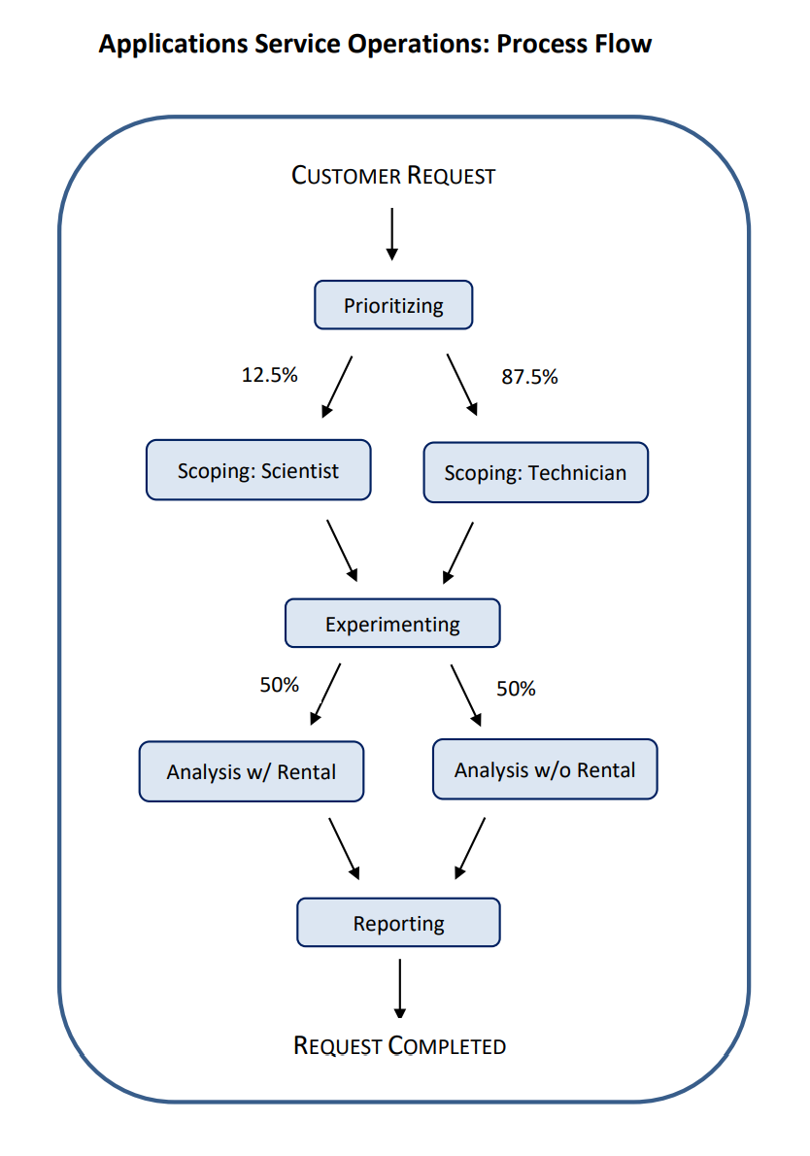

The first step of the process is Prioritizing. This process will determine if the request represents a project that should be handled by a scientist or a technician. When the request is handled by either a scientist or a technician, it will go for the experimenting part of the process. The scoping process will be handled by two different groups. Then after that, the request will be sent to the reporting phase.

The chart below shows how many requests the average workers in each process can complete per day, their location, and daily labor cost.

| Process | Location | Average Capacity per Worker (customers/day) | Labor Cost per Worker ($/day) |
| --- | --- | --- | --- |
| Prioritizing | Puerto Rico | 12 | 125 |
| Scoping: Scientist | Wichita | 3 | 400 |
| Scoping: Technician | Wichita | 7 | 250 |
| Experimenting | Bangladesh | 6 | 75 |
| Analyzing w/o Rental | Wichita | 6 | 300 |
| Analyzing w/Rental | Wichita | 2 | 350 |
| Reporting | Philippines | 8 | 50 |

To make sure the daily demand is met. The minimum number of workers for the different processes is shown in the table below:

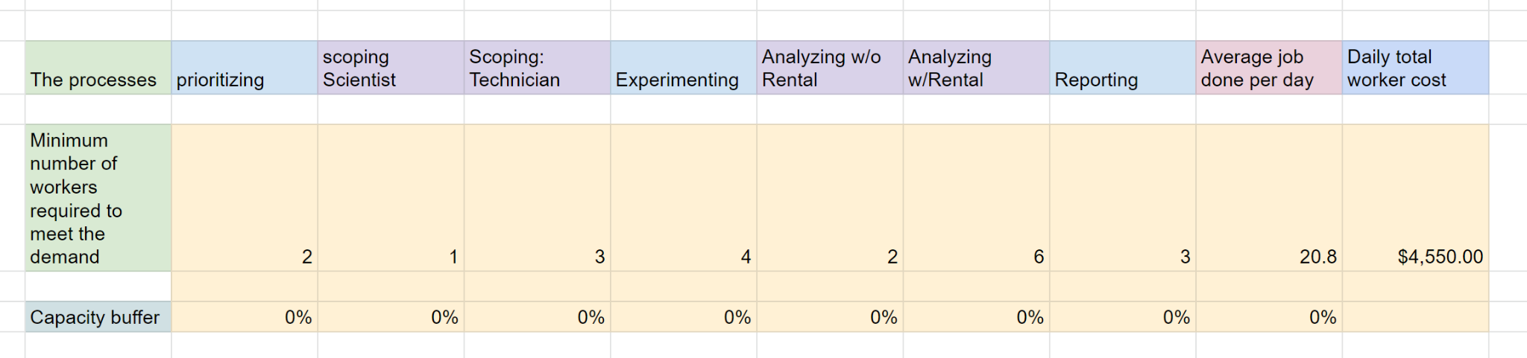

Prioritizing: 12x2= 24

Scoping: Scientist: 3x1= 3 (12.5 %)

Scoping: Technician: 7x3= 21 (87.5%)

Experimenting: 6x4= 24

Analyzing w/o Rental: 6x2= 12(50%)

Analyzing w/Rental: 2x6= 12 (50%)

Reporting: 8x3= 24

For our process to run and meet the average processing demand of 24, we would need at least 4 workers for prioritizing, one scientist, three technicians, 4 workers for experimenting, 8 total analyzing workers and 3 reporting workers.

Because the capacity buffer is 0%, the process cannot handle any request that crosses the 24 number. Due to many uncertainties and backlogs, our simulations show that this minimum number of workers cannot meet the daily average demand of 24.

The graph below shows the anticipated demand in the blue line and the results with 0% capacity buffer.

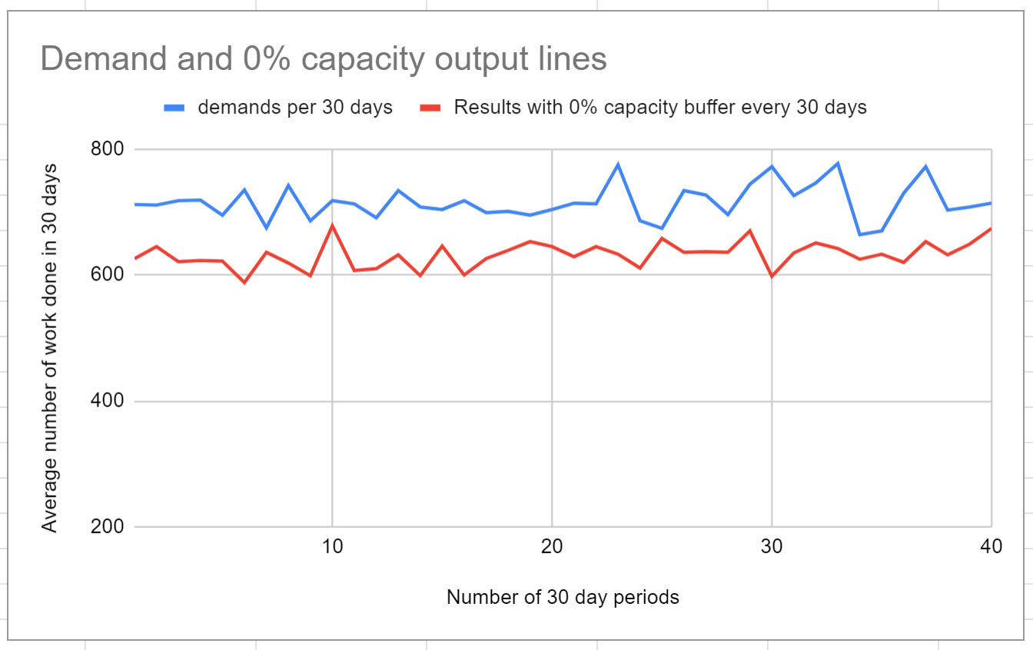

The graph below shows the standard deviation of the number of requests completed with a 0% capacity buffer in each of the process categories. We can see that the average is always below 24 works per day.

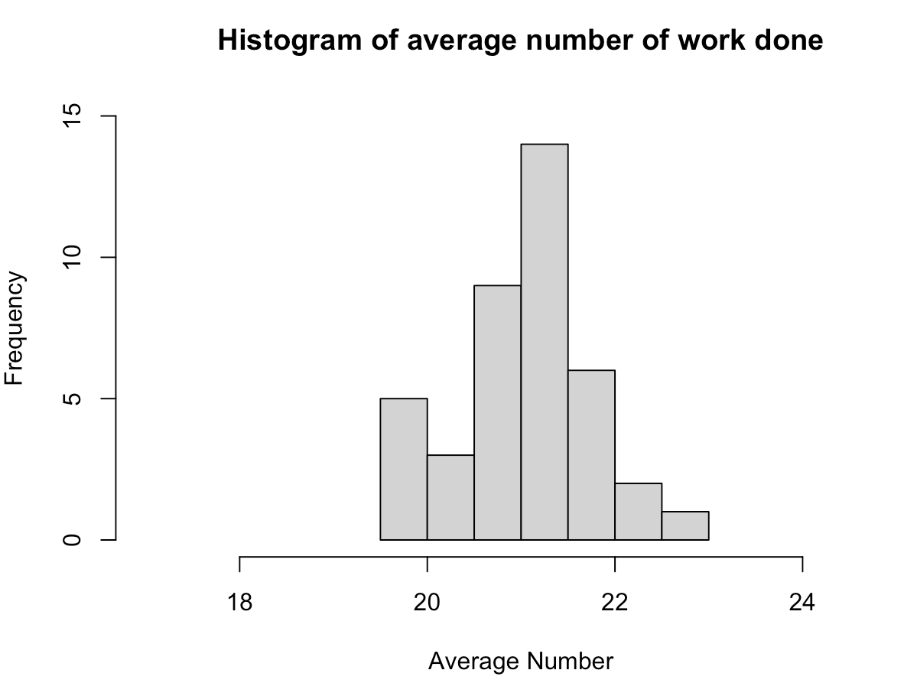

Standard deviation= 0.70

Results with the Optimum number of workers

After running the simulation repeatedly with different combinations of workers each time, we have come up with the optimum number of workers needed for each of the processes for the operations to run smoothly.

They are 4 workers in prioritizing, 3 scoping scientists, 5 scoping technicians, 7 experimenting workers, 12 total analyzing workers, and 5 reporting workers.

The graph below shows the optimum number of workers, each department’s capacity buffer, average job done, daily cost, and 95% confidence interval:

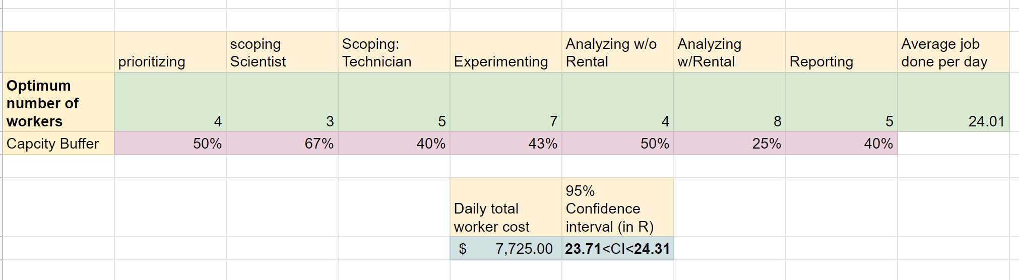

With this optimum number of workers, the average number of jobs done per day is 24. The 95% Confidence Interval is between 23.71 and 24.31 jobs done per day. This is a very good indicator that the operation is going to have a minimum backlog and a smooth workflow. The capacity buffer for each process is quite high and can handle a noticeably high number of demands.

Even though the daily worker cost is quite a bit higher here than the minimum worker cost, we believe it is a necessary cost. As the higher number of workers makes the process more efficient and smooth, we will be able to process more demands overall. This will increase our sales and will have a positive impact on our reputation.

The graph below shows the average work done per day by the minimum number of workers in blue and the average work done per day by the optimum number of workers in yellow. The average demand per day is shown by the red line. We can see that the optimum number of workers consistently meets the average demand while the minimum number of workers cannot.

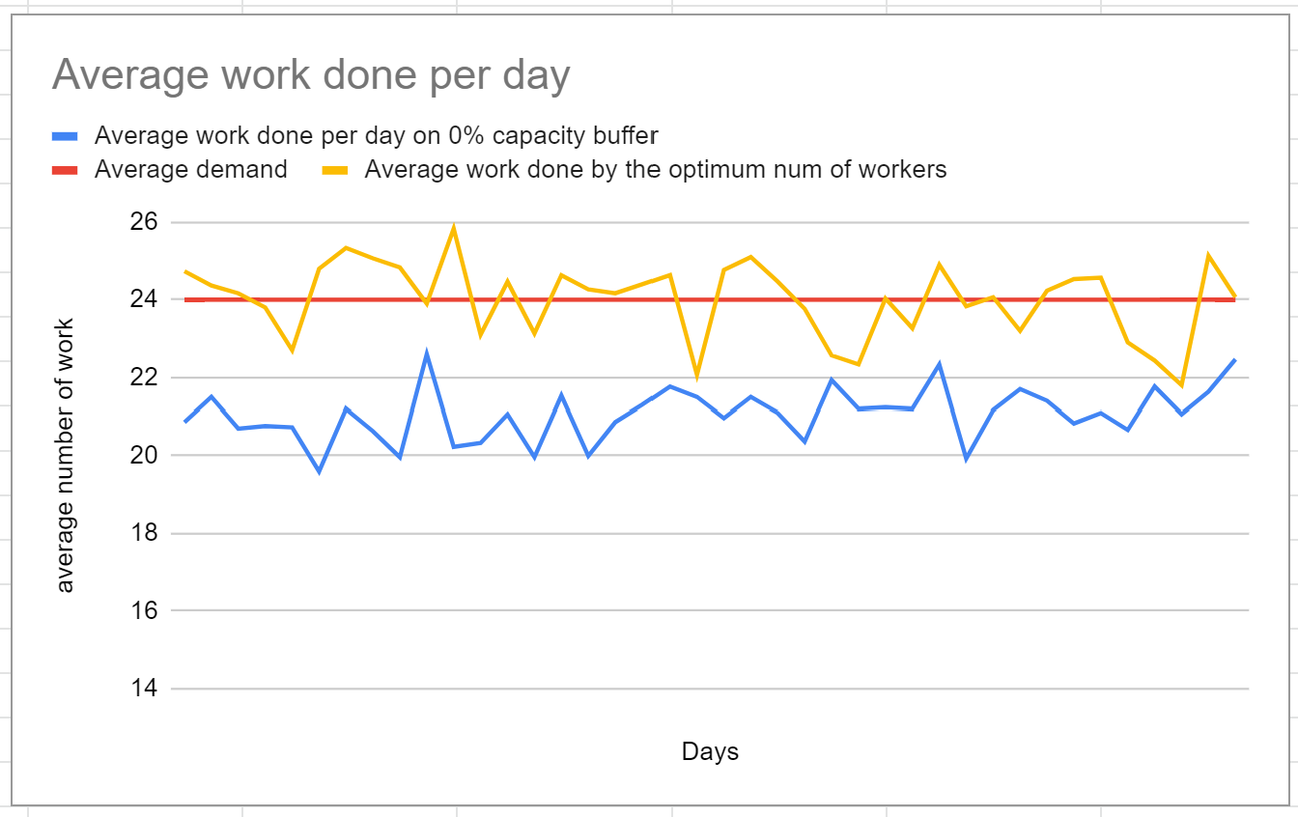

Other Alternatives

We looked at quite a few alternatives to reduce the number of workers and the cost. However, they did not perform well in terms of meeting the daily demand.

The chart below shows the two alternatives we considered:

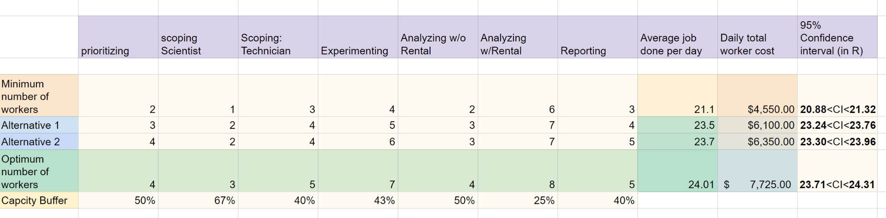

As you can see, the cost is significantly lower for the two alternatives than the optimum number of workers. However, none of the alternatives have an average output of over 24/day. The 95% Confidence Interval chart below shows the reason we decided to go with the costly alternative.

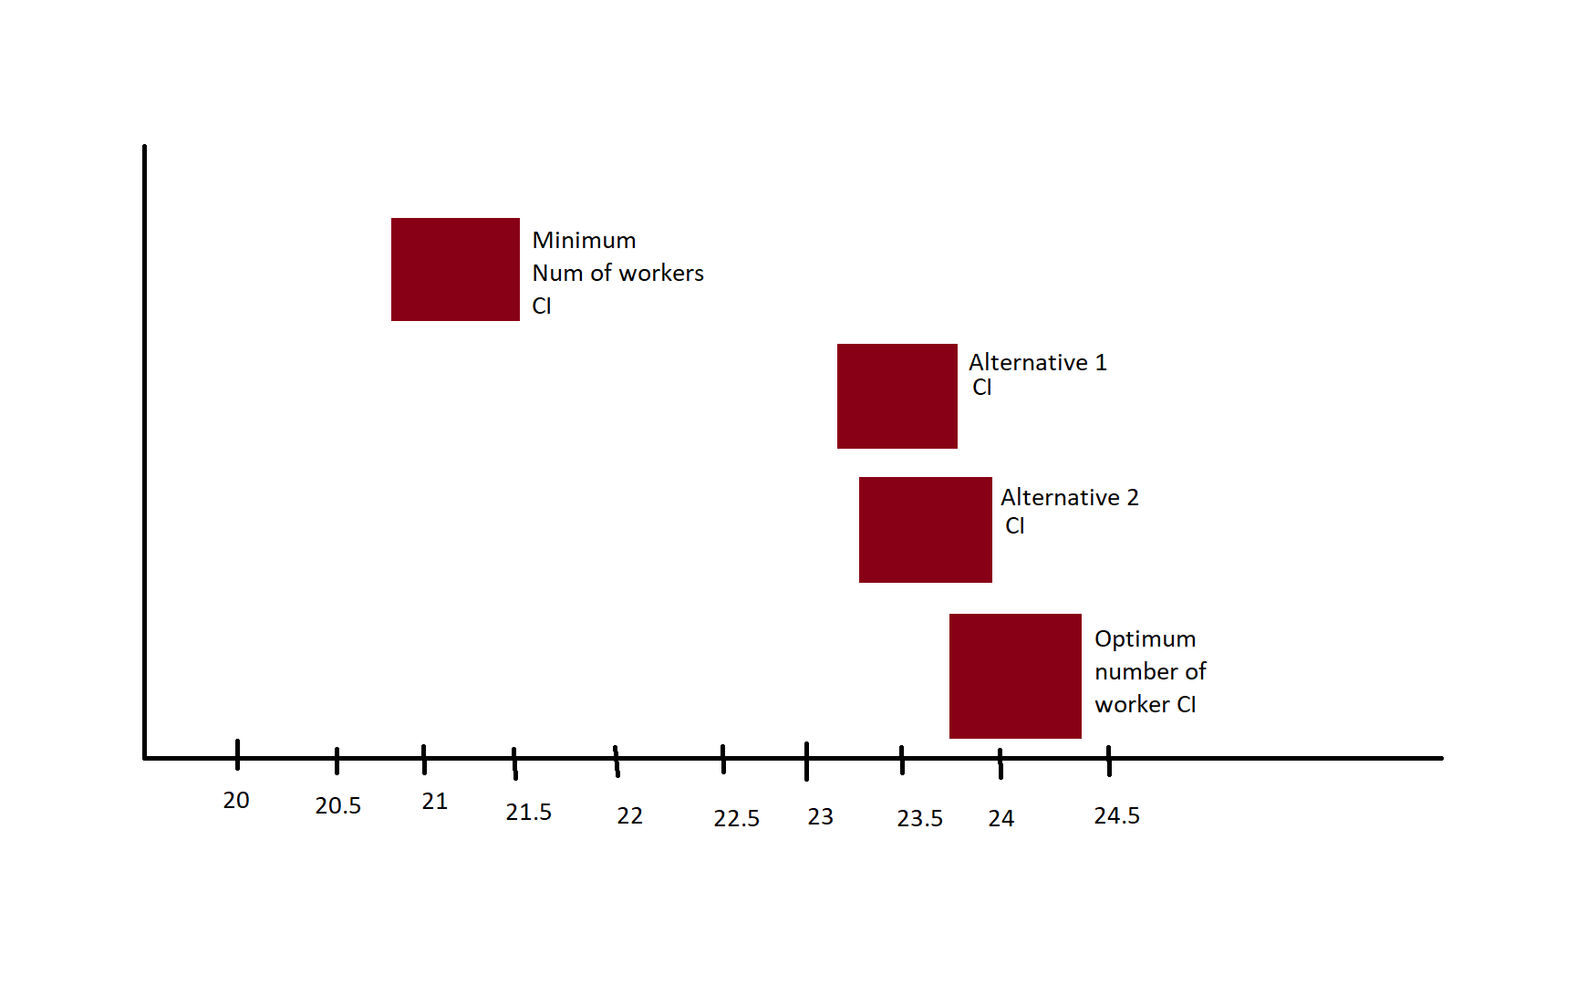

Here you can see that the two cheaper alternatives will almost always give a daily output below 24 works/day. Stickly will need the daily average output to be over 24 works/ day to meet the average demand.

Potential problems with centralization

Even though a centralized process will make the system more efficient, there are some potential problems that may arise and we need to take note of them. Below we will discuss four of the most common problems:

**Performance Issues:** One potential problem that may occur if a centralized system were implemented is performance issues. According to P. Jayapandian and K. Ilango (2014), a centralized system can become a performance bottleneck because it has a single point of failure, which can cause system downtime, slow response time, and decreased overall system performance.

**Data Security Risks:** Another potential problem that may occur if a centralized system were implemented is data security risks. According to A. M. Alhassan and J. C. Opara-Martins (2020), a centralized system can be vulnerable to cyberattacks and unauthorized access, which can result in data breaches and loss of sensitive information.

**Scalability Issues:** A third potential problem that may occur if a centralized system were implemented is scalability issues. According to S. S. Sangeetha and S. Sumathi (2017), a centralized system can become difficult to scale as the system grows, which can result in reduced system availability and increased system maintenance costs.

**Single Point of Failure:** A centralized system has a single point of failure, meaning if the central server goes down, the entire system becomes unavailable. This can lead to significant losses for businesses that rely on the system, including loss of revenue, productivity, and customer trust. A peer-reviewed article by Bryant. (2013) suggests that centralized systems have a single point of failure and are vulnerable to system downtime.

Conclusion

In conclusion, this report looks at the service capacity requirements. It looks at the capacity buffer, daily cost of workers, and 95% confidence intervals for the daily average work to determine the optimum number of workers needed for the service. It bases all of its conclusions on previously done research and the simulation created based on previous analysis.

Reference

Jayapandian, P., & Ilango, K. (2014). Performance evaluation of centralized and distributed database systems. International Journal of Advanced Research in Computer Science and Software Engineering, 4(1), 1-8.

Alhassan, A. M., & Opara-Martins, J. C. (2020). A review of centralized, decentralized and blockchain-based database systems. Journal of Information Security and Applications, 52, 102509.

Sangeetha, S. S., & Sumathi, S. (2017). Performance analysis of centralized and distributed database systems. International Journal of Computer Science and Mobile Computing, 6(11), 20-29.

Bryant. (2013). Identifying single points of failure in your organisation. Journal of Business Continuity & Emergency Planning, 7(1), 26–32.

Appendix

<https://docs.google.com/spreadsheets/d/19Ov8ImuEArcE-u3c5U77TUokBTxwJZrjDhlGQ9YQBRM/edit?usp=sharing>